H.T No
Regulations:
A18

Sreenidhi Institute of Science and Technology
(An Autonomous Institution)
Code No: 7AC48 Date: 02-Jan-2023 (FN)

B.Tech II-Year II- Semester (A18) Special Supplementary Examination - December-2022
ELECTRICAL AND ELECTRONICS ENGINEERING (CIVIL and ME)

Time: 3 Hours Max.Marks:70

Note: a) No additional answer sheets will be provided.
b) All sub-parts of a question must be answered at one place only, otherwise it will not be valued.
c) Missing data can be assumed suitably.

ANSWER ANY 5 OUT OF 8 QUESTIONS. EACH QUESTION CARRIES 14 MARKS.

Bloom's Cognitive Levels of Learning (BCLL)
Remember | L1 | Apply | L3 | Evaluate | L5
Understand | L2 | Analyze | L4 | Create | L6

 |  |  | BCLL | CO(s) | Marks
1. | a) | Explain different methods of excitation of D.C. generators with suitable diagrams. | L2 | CO1 | [7M]
 | b) | Find the resistance between the points A and B in the series-parallel network shown in below Fig  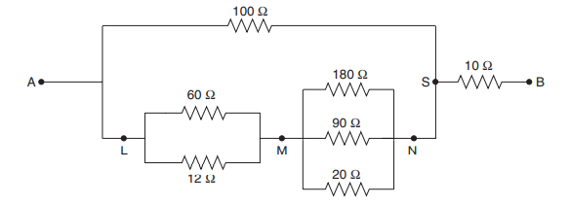 | L3 | CO1 | [7M]
2. | a) | Explain the relationship between voltage and current in a R-L series circuit with necessary phasor diagrams. | L2 | CO2 | [7M]
 | b) | In a series circuit consisting of pure resistance and pure inductance, the current and voltage are expressed as: i(t)=5sin(314t+2π/3) and v(t)=15sin(314t+5π/6).  What is the  i) impedance of the circuit?  ii) value of resistance?  iii) inductance in Henry?  iv) average power drawn by the circuit?  v) What is the power factor? | L5 | CO2 | [7M]
3. | a) | Describe with a neat diagram, the principle of operation of induction motor. | L2 | CO3 | [7M]
 | b) | Differentiate between an absolute instrument and a secondary instrument. | L2 | CO3 | [7M]
4. | a) | Explain the V-I characteristics of Zener diode in detail. | L1 | CO4 | [7M]
 | b) | Explain about the classification of clampers. | L5 | CO4 | [7M]
5. | a) | Draw the circuits of the various transistor configurations and list their important features. | L3 | CO5 | [7M]
 | b) | Give reasons why CE configuration is mainly used? | L3 | CO5 | [7M]
6. | a) | Explain about minimization of SOP of two variable using K-map. | L4 | CO6 | [7M]
 | b) | What is the only input combination that will produce a HIGH and LOW at the output of a five input OR-gate? Explain. | L5 | CO6 | [7M]
7. | a) | Find the current through the 2Ω resistor of the network in below Figure.  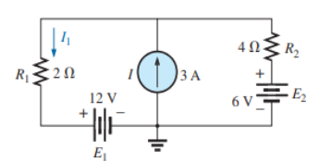 | L3 | CO1 | [5M]
 | b) | Define the following terms as applied to an alternating current: Cycle, frequency, time period and amplitude. | L2 | CO2 | [5M]
 | c) | Give the importance of controlling torque in the measuring instruments. | L2 | CO3 | [4M]
8. | a) | Explain about the classification of clippers. | L4 | CO4 | [5M]
 | b) | Explain the physical operation of JFET | L4 | CO5 | [5M]
 | c) | How are binary and octal related? Explain. | L3 | CO6 | [4M]

-- 00 -- 00 –

